**Field Work**

**On**

**Garena Free Fire**

**Submitted to**

**KCES’s Institute of Management and Research, Jalgaon**



**Submitted by**

**Name: Mr. Pranav Sunil Patil**

**Email id: pp3850397@gmail.com**

**Under the Guidance of**

**Name**: **Miss. Ashwani Patil**

**In Partial Fulfillment of**

**Master of Computer Application ( Integrated)**

**KCES’s Institute of Management and Research, Jalgaon**

**ACKNOWLEDGEMENT**

We have great pleasure in submitting this Field Work on **“Garena Free Fire”** to **KCES’s Institute of Management and Research, Jalgaon.**

It is humble brief that any Field Work can be carried out with success by a two person. Many other personalities helpings to accomplished this project and it is our duty to express our appreciation to them.

We are indebted to **Mrs. Ashwani Patil** for helping us as guide and allow up do the Field Work at their site.

We wish to thank the teaching staff, our friends and persons who help us directly or indirectly for completion of Field Work.

**DECLARATION**

We hereby declare that the project work entitled “Garena Free Fire – A Study on Its Social and User Impact” has been carried out by us under the guidance of Miss Aarati Hinge. We further declare that this work has not been submitted in part or full to any other university or institute for the award of any other degree. All materials obtained from other sources have been duly acknowledged.

**INDEX**

| **Sr. No.** | **TOPIC** | **Page No.** |
| --- | --- | --- |
| **1** | **Abstract** | **5** |
| **2** | **Introduction** | **6** |
| **3** | **Project Field Work Topic / Literature Review** | **7** |
| **4** | **Objectives** | **9** |
| **5** | **Methodology** | **10** |
| **6** | **Result and Discussion** | **12** |
| **7** | **Recommendations and Future Work** | **14** |
| **8** | **Suggestion** | **15** |
| **9** | **Conclusion** | **16** |
| **10** | **References** | **17** |
| **11** | **Questionnaire** | **18** |

**1.Abstract**

Garena Free Fire is a world-famous battle royale game that allows 50 players to compete on an island until only one survives. The game’s success lies in its accessibility, fast-paced gameplay, and interactive design that appeals to both casual and professional players.  
Free Fire has become not just a game but a **digital community**, connecting millions of players through online teamwork and social interaction.

It offers players a chance to improve their **decision-making, coordination, and reflexes**, which are essential skills both in and outside gaming. The study focuses on how Free Fire influences the lives of young players—how it encourages communication, teamwork, and entertainment, but also how it sometimes leads to **addiction, distraction, and social isolation**.

Additionally, the report examines how gaming has evolved into a form of digital culture and how Free Fire has built a sense of community among users. Overall, the study aims to understand the **positive and negative social impact** of Garena Free Fire on today’s youth

**2. Introduction**

Garena Free Fire was launched in 2017 by **111 Dots Studio** and published by **Garena**. Within a short period, it became one of the most downloaded mobile games worldwide, especially in countries like India and Brazil. The main attraction of Free Fire is its easy-to-learn mechanics, engaging graphics, and short, action-filled matches.

The game provides opportunities for **social interaction**, teamwork, and communication through squad modes and voice chats. Many young people use it as a way to make friends and connect virtually.

However, the rising trend of mobile gaming also brings challenges such as **addiction, reduced study time, and health concerns** due to prolonged screen exposure.  
This project aims to understand both sides — the **benefits** of entertainment, learning, and teamwork, as well as the **drawbacks** such as addiction and distraction.

Free Fire has also become a **career option** for many through live streaming, YouTube gaming channels, and e-sports tournaments, proving that digital gaming has both cultural and economic importance.

**3.Project Field Work Topic / Literature Review**

Studies show that online games like Garena Free Fire influence both **psychological behavior** and **social interaction** among youth.

1. **Positive Effects:**  
   Research indicates that gaming improves decision-making skills, reaction time, and problem-solving abilities. Multiplayer games also help in teamwork and cooperation.
2. **Social Interaction:**  
   Free Fire helps players build friendships and a sense of belonging. It encourages communication between players from different backgrounds, promoting diversity and collaboration.
3. **Negative Impact:**  
   According to studies, excessive gaming can lead to anxiety, aggression, or poor academic performance. The “reward loop” in games creates dependency and affects time management.
4. **Gender and Gaming:**  
   Many reports highlight that female gamers are increasingly participating in Free Fire, creating a more inclusive online gaming culture.
5. **E-sports and Digital Economy:**  
   The rise of Free Fire tournaments has made e-sports a real career path, generating income through sponsorships and live streams.

This literature review suggests that **Garena Free Fire has both constructive and concerning effects**, depending on how responsibly players engage with it.

**4.Objectives**

To study the popularity and user engagement level of Garena Free Fire among youth.  
 • To examine the social and psychological impact of gaming on users.  
• To understand the role of teamwork and communication within the game.  
• To analyze positive outcomes such as stress relief and coordination skills.  
• To identify the challenges and negative effects of excessive gaming.  
• To provide recommendations for balanced and responsible gaming habits

• To study the growing popularity of Garena Free Fire among college students and youth.  
• To identify how gaming influences communication, teamwork, and leadership.  
• To explore how online games contribute to stress relief and social bonding.  
• To examine challenges such as addiction, reduced productivity, and time misuse.  
• To understand the perception of gaming as a form of digital entertainment and career.  
• To provide suggestions for responsible gaming habits among students.

**5. Methodology**

The research followed a **descriptive survey method** to understand players’ behavior and gaming patterns.

1. **Data Collection:**
   * Primary data was collected using questionnaires and interviews from 80 respondents who play Free Fire regularly.
   * Secondary data came from articles, online reports, and academic studies related to gaming psychology.
2. **Sampling Technique:**
   * Random sampling was used to ensure that respondents represented different genders, age groups, and education levels.
3. **Tools Used:**
   * Data was analyzed using simple graphs and percentages to interpret how gaming affects users socially and mentally.
4. **Procedure:**
   * Respondents were asked questions about their gaming frequency, motivations, emotional changes, and time spent playing.
5. **Limitations:**
   * Some responses may be biased.
   * Limited to Free Fire players in a specific region.

This methodology helps present a **balanced overview** of gaming habits and their social influence.

**6. Results and Discussion**

The survey revealed the following observations:

• Most respondents play Free Fire for **fun and stress relief** rather than competition.  
• About **70%** of players said the game helps them make friends and communicate better.  
• **25%** admitted to spending more than three hours daily, affecting their studies or sleep.  
• Players said teamwork and strategy in squad matches improved their **coordination and leadership skills**.  
• Some players experienced mild irritation or frustration after losing matches, showing emotional impact.

**Discussion:**  
Free Fire promotes entertainment, social bonding, and quick thinking. However, excessive playtime can lead to reduced attention span and poor academic focus.  
The study also found that players often feel motivated and happy while playing, showing the **positive emotional benefits** of gaming.  
Thus, while Free Fire provides valuable learning experiences in teamwork and planning, it must be played in moderation.

**7. Recommendations and Future Work**

• Introduce awareness programs promoting healthy gaming habits.  
• Parents and educators should monitor gaming duration and behavior.  
• Developers should include in-game reminders for breaks and screen time limits.  
• Future studies could explore Free Fire’s role in e-sports career development and digital literacy.  
• Explore mental health impacts of gaming in a post-pandemic digital environment

• Conduct awareness sessions in colleges about healthy gaming habits.  
• Parents and teachers should encourage students to balance gaming and studies.  
• Developers should include **auto-reminders** for playtime limits.  
• Future research can explore **the role of gaming in skill development** and **career building in e-sports**.  
• Organize school and college tournaments under supervision to promote responsible play.  
• Explore the impact of Free Fire on emotional intelligence and decision-making in youth..

**8.Suggetions**

Play responsibly by limiting screen time.  
• Balance gaming with academic and physical activities.  
• Avoid in-game purchases and addiction to rewards.  
• Encourage multiplayer games for team building rather than solo play.  
• Use gaming as a medium for communication, not isolation

• Limit gaming time to less than 2 hours daily.  
• Use Free Fire as a **tool for socializing and teamwork**, not escapism.  
• Avoid excessive spending on in-game items.  
• Encourage parents to understand gaming culture rather than banning it.  
• Use gaming breaks for learning stress control and quick decision-making.

**9. Conclusion**

Garena Free Fire has become more than just a mobile game—it is a global digital community influencing millions of users. It enhances teamwork, focus, and social interaction but also brings challenges like addiction and distraction if not regulated. With balanced playtime, awareness, and parental guidance, Free Fire can continue to be a source of learning, recreation, and connection in the digital age.

Garena Free Fire has created a massive global impact by merging entertainment, technology, and social connection. It helps develop teamwork, coordination, and stress management but also poses risks when played without balance.  
The study concludes that **gaming is not harmful by itself** — rather, its effects depend on how players manage their time and emotions.  
With balanced use and awareness, Free Fire can be seen as a **modern form of recreation and communication**, connecting millions across the world while teaching valuable life skills.

**10. References**

• Gupta, R., & Sharma, P. (2022). Online Gaming and Youth Behavior: A Psychological Study. Indian Journal of Digital Studies.  
• Singh, V. (2023). The Social Dynamics of Multiplayer Gaming. Journal of Media and Culture.  
• Kumar, A., et al. (2022). Effects of Mobile Gaming on Academic Performance. Journal of Education and Psychology.  
• World Health Organization (2021). Gaming Disorder: Public Health Classification.  
• Garena (2024). About Free Fire. Retrieved from <https://ff.garena.com/>

**11. Questionnaires**

Forms response chart. Question title: 1.  How often do you play Free Fire?
. Number of responses: 101 responses.Forms response chart. Question title: 2.How many hours per session do you spend playing Free Fire?
. Number of responses: 101 responses.Forms response chart. Question title: 3.What device do you primarily use for Free Fire?
. Number of responses: 101 responses.

Forms response chart. Question title: 4. What is your preferred game mode in Free Fire?
. Number of responses: 102 responses.

Forms response chart. Question title: 5.Which map do you like most?
. Number of responses: 103 responses.Forms response chart. Question title: 6.Do you usually play solo, duo, or squad?

. Number of responses: 103 responses.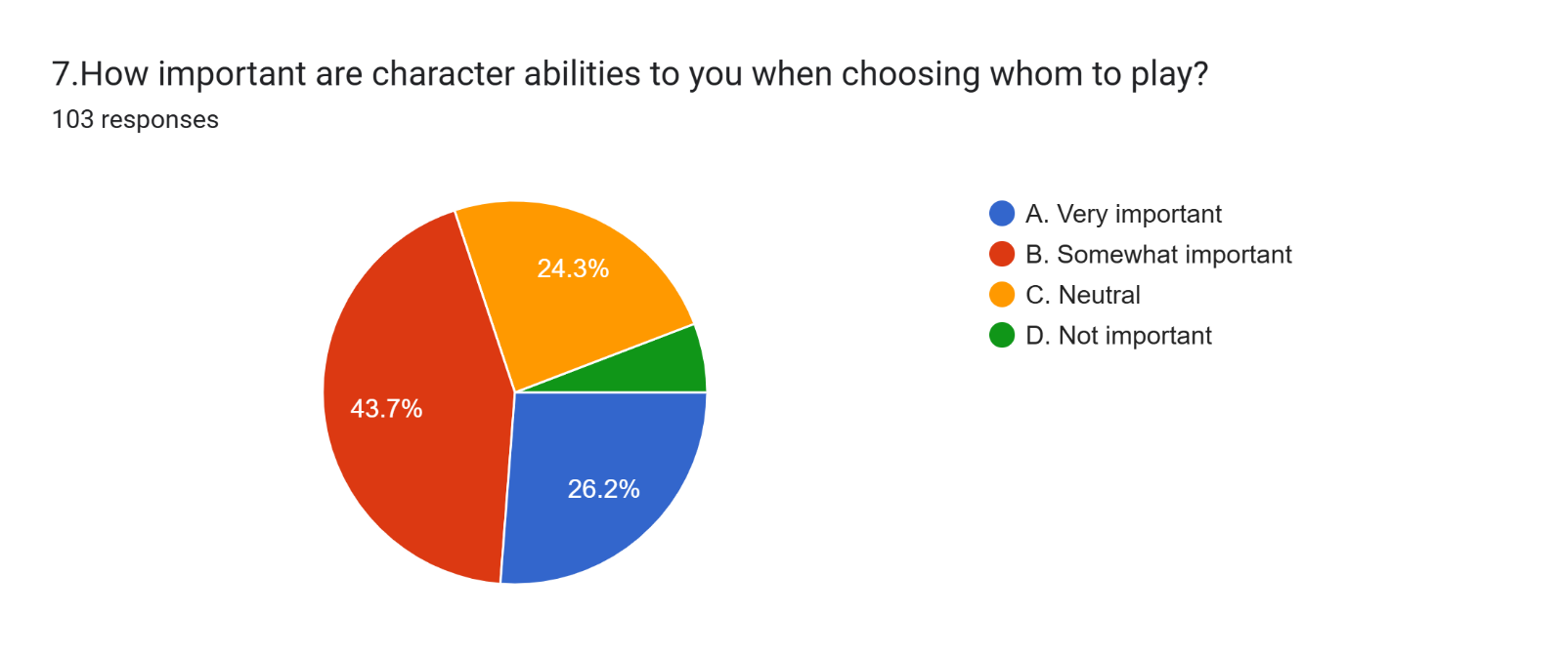Forms response chart. Question title: 8. Do you buy Elite Pass / Battle Pass?
. Number of responses: 103 responses.Forms response chart. Question title: 9. How much do in‑game rewards / skins influence your enjoyment of the game?
. Number of responses: 104 responses.Forms response chart. Question title: 10. How satisfied are you with Free Fire’s graphics / visuals?

. Number of responses: 104 responses.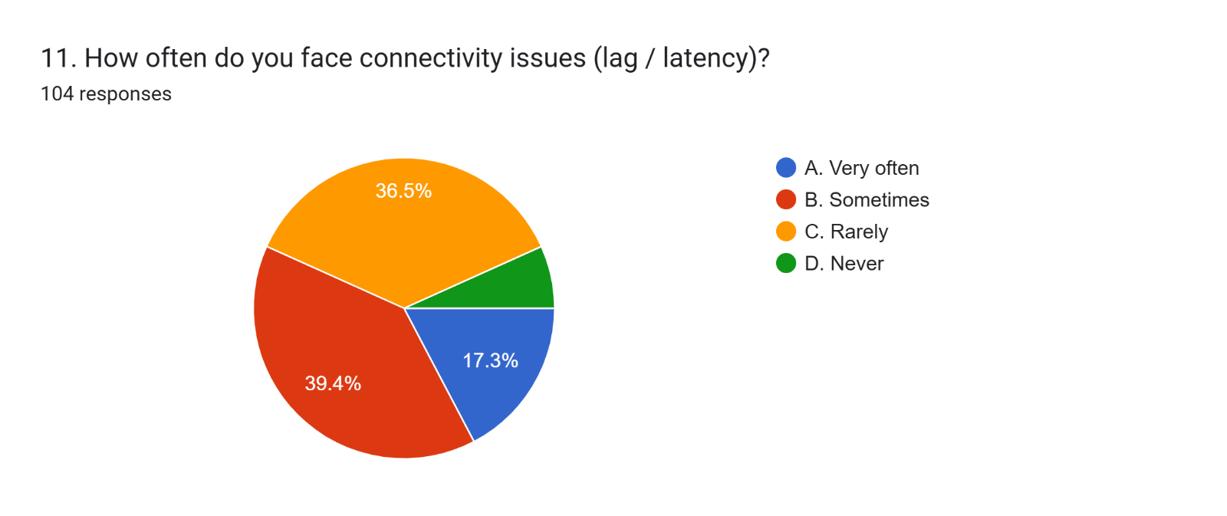Forms response chart. Question title: 12. Do you feel the in‑game matchmaking is fair?

. Number of responses: 104 responses.Forms response chart. Question title: 13. Which weapon type do you prefer using?

. Number of responses: 104 responses.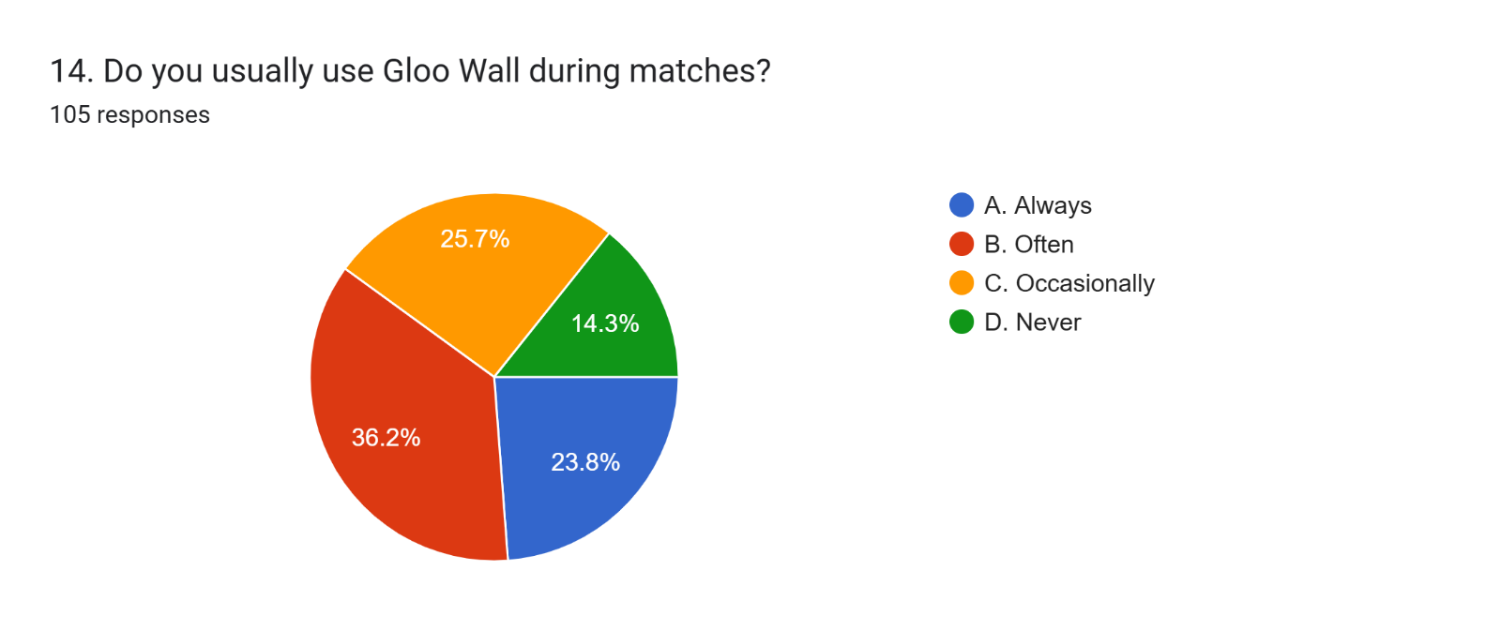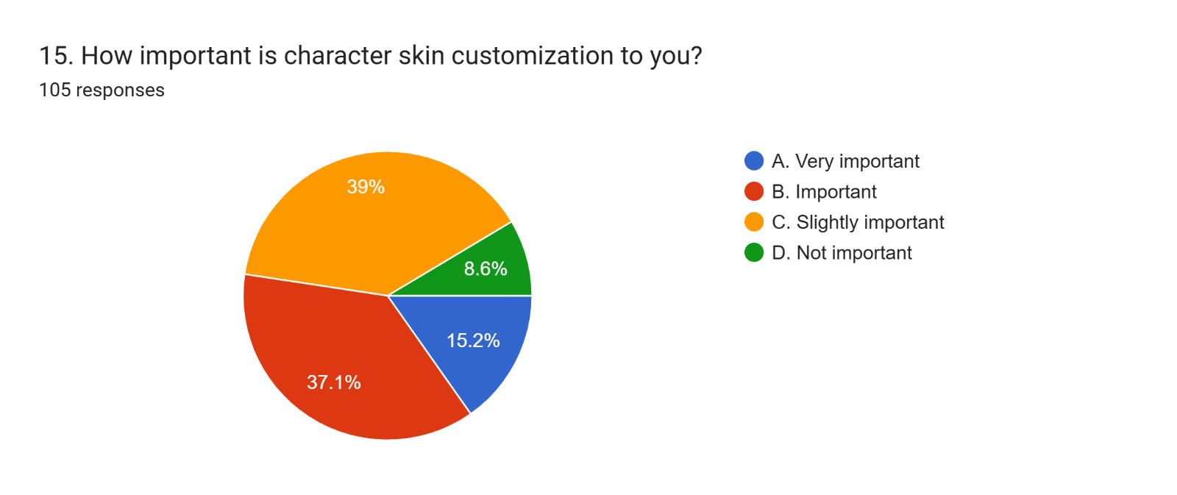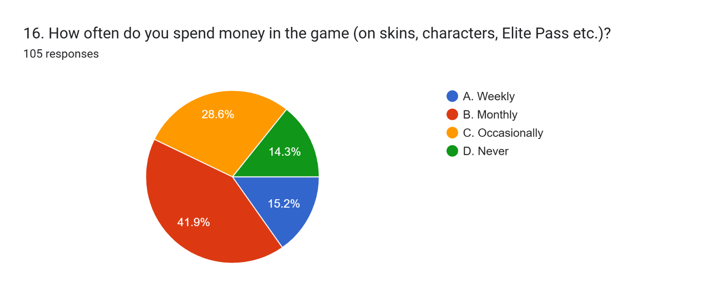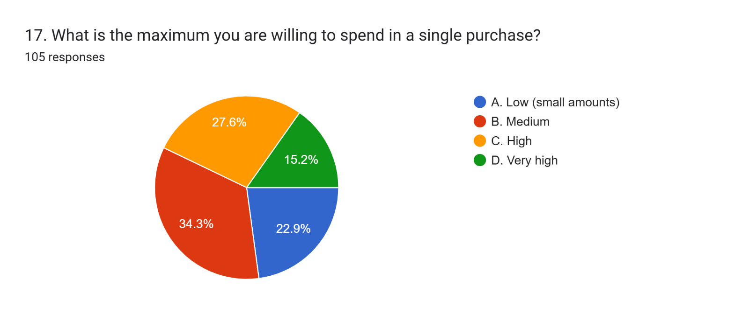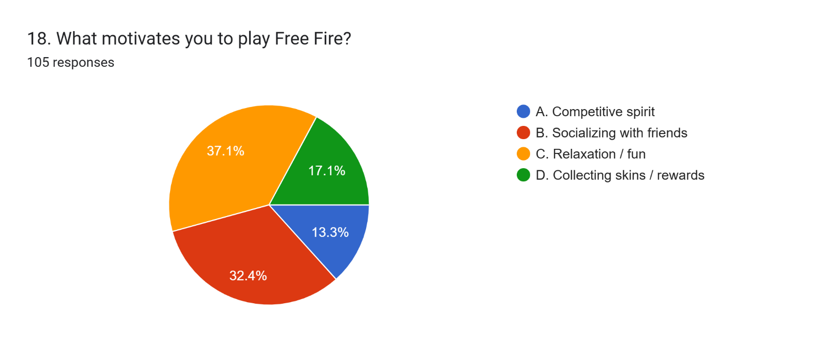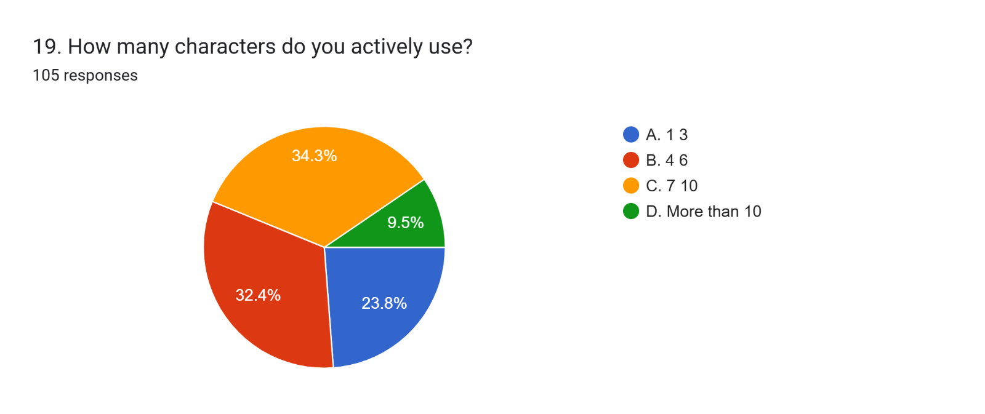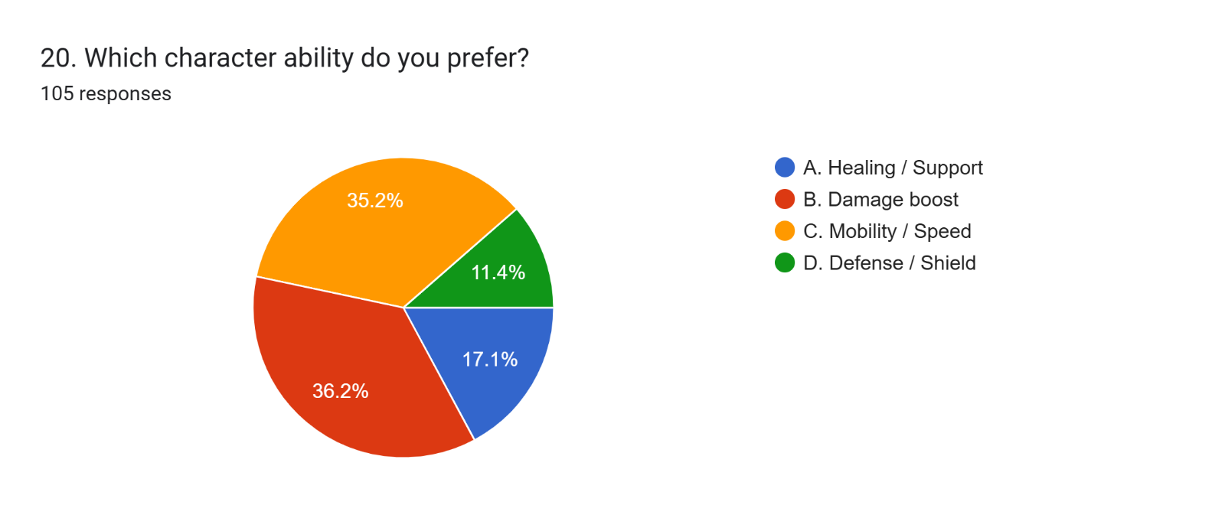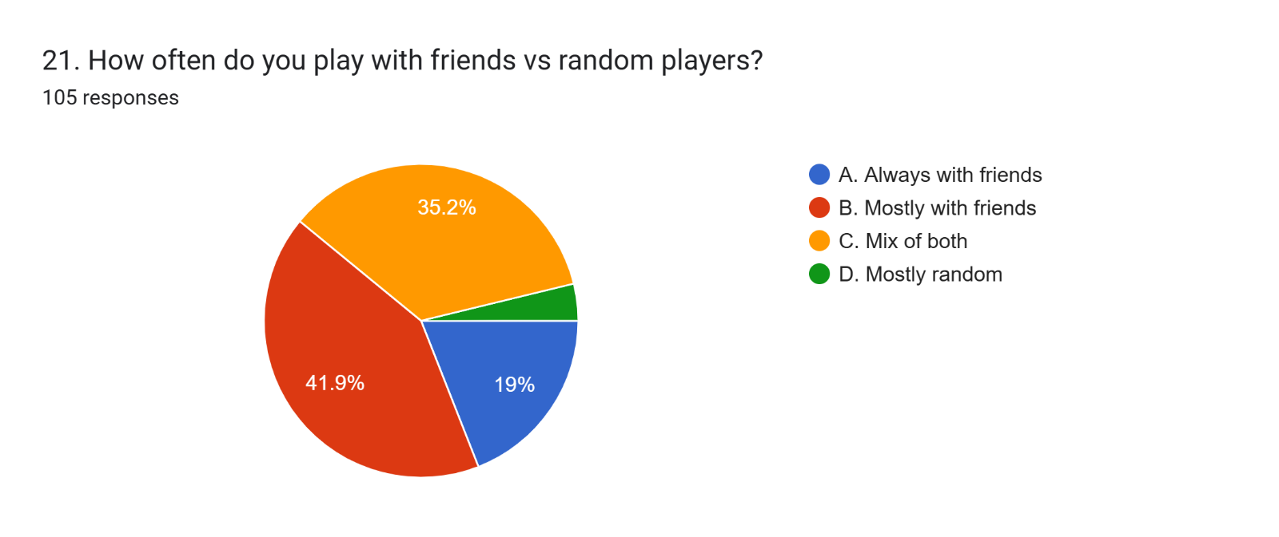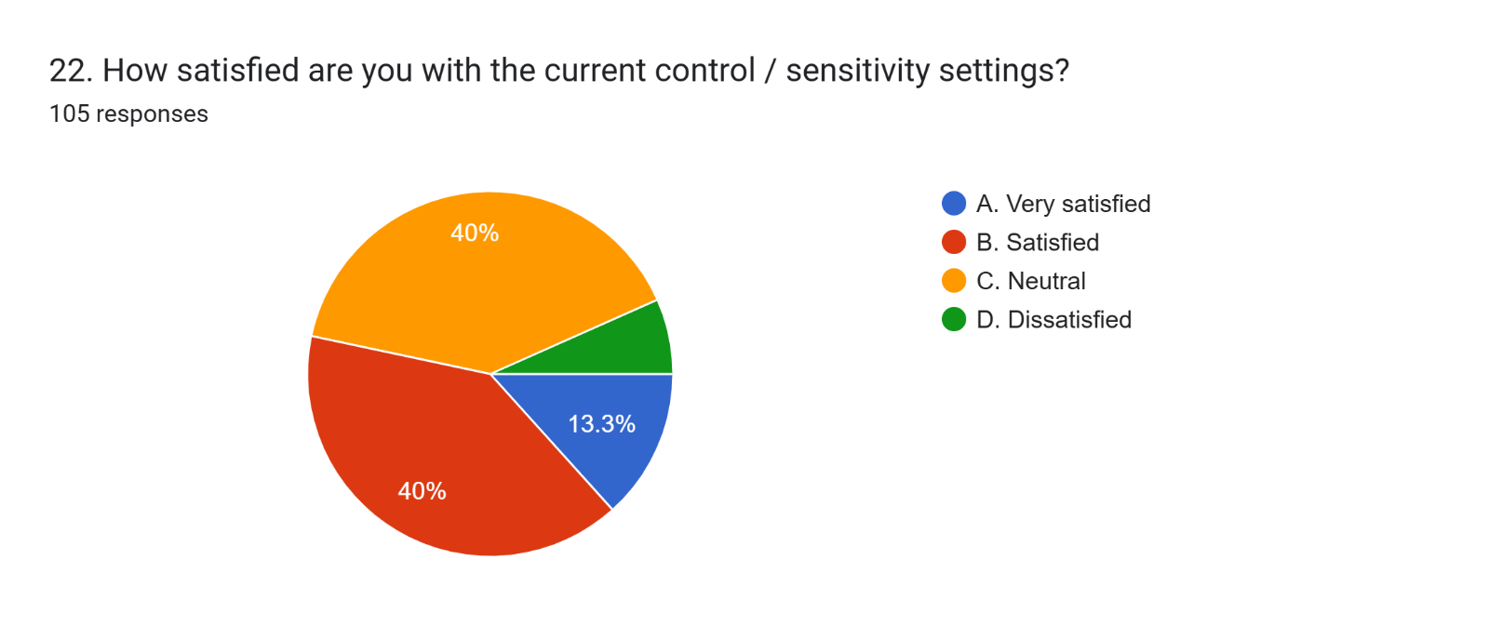Forms response chart. Question title: 23. Do you use third‑party peripherals / controllers?
 . Number of responses: 105 responses.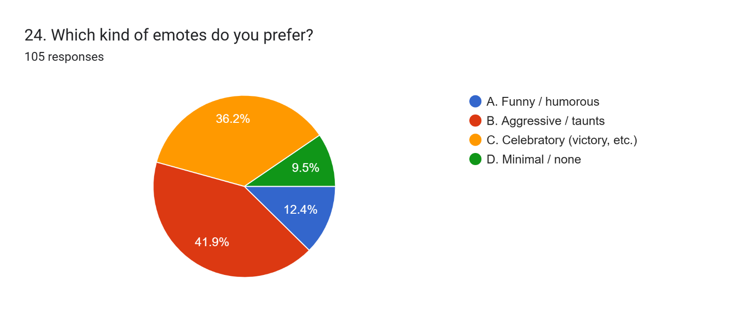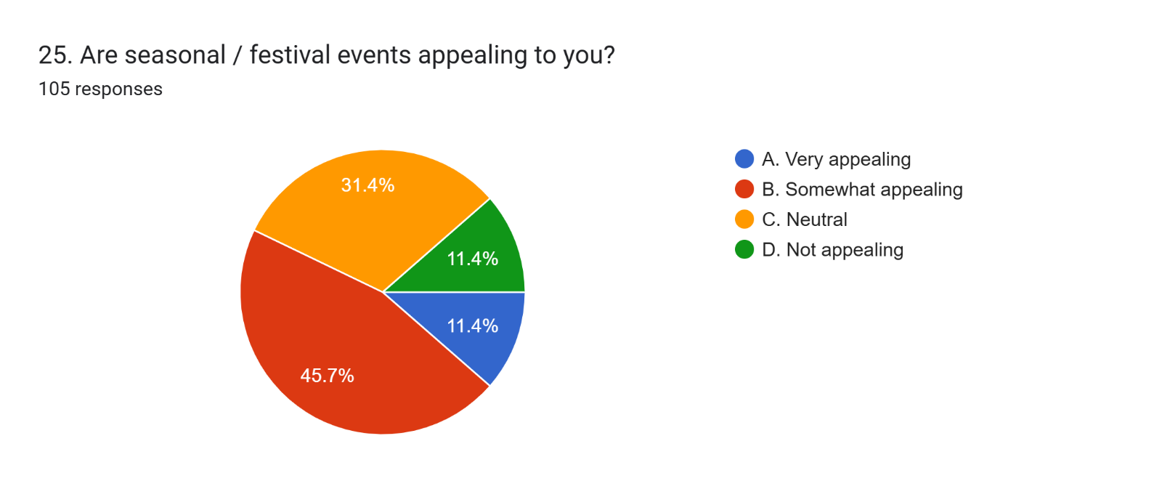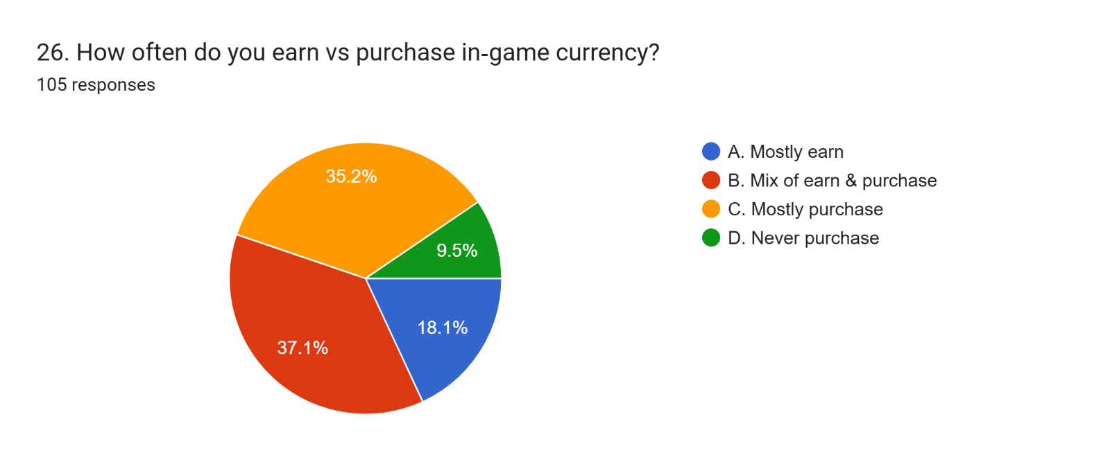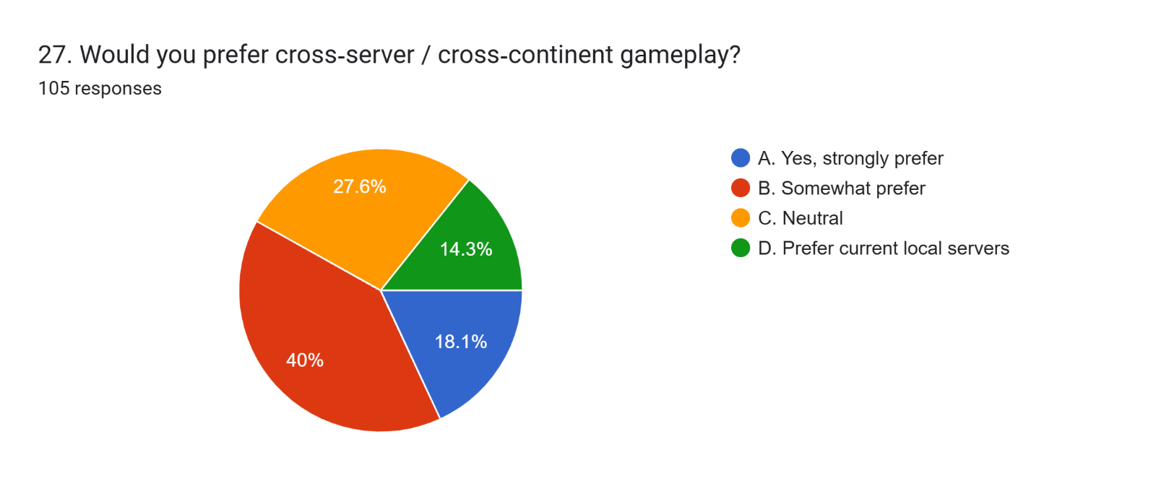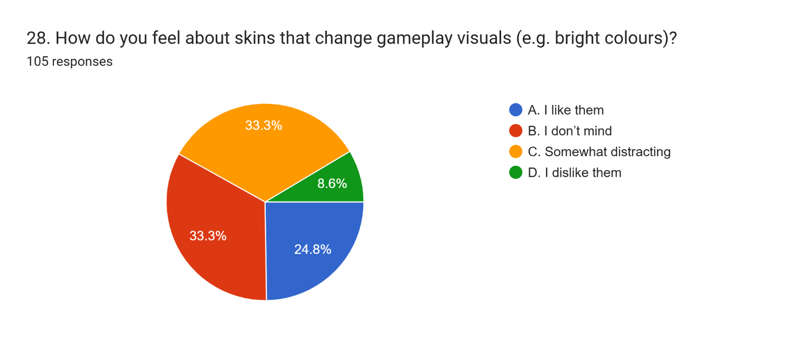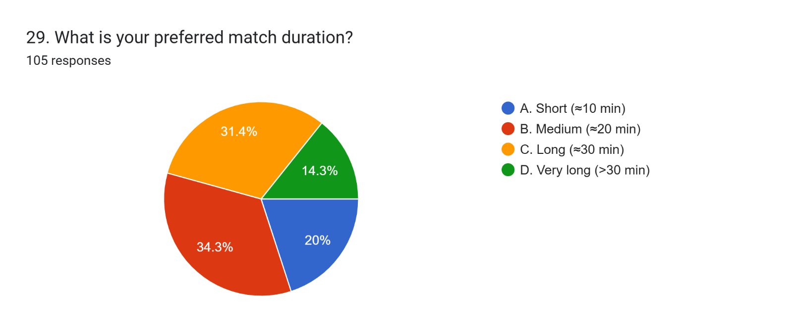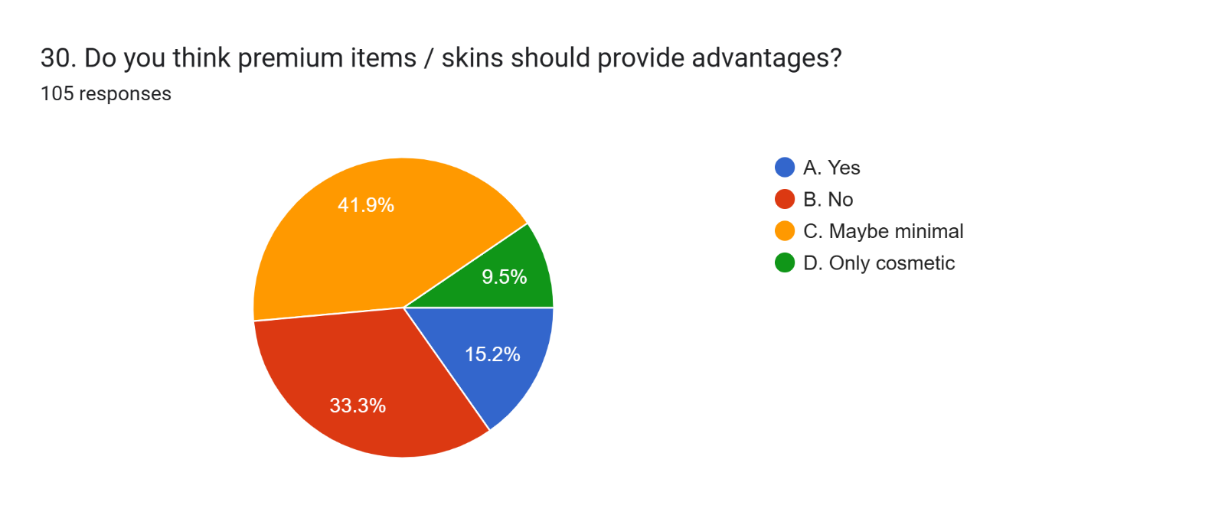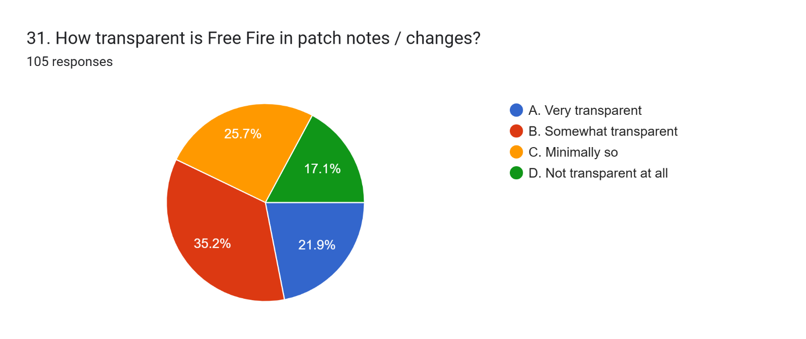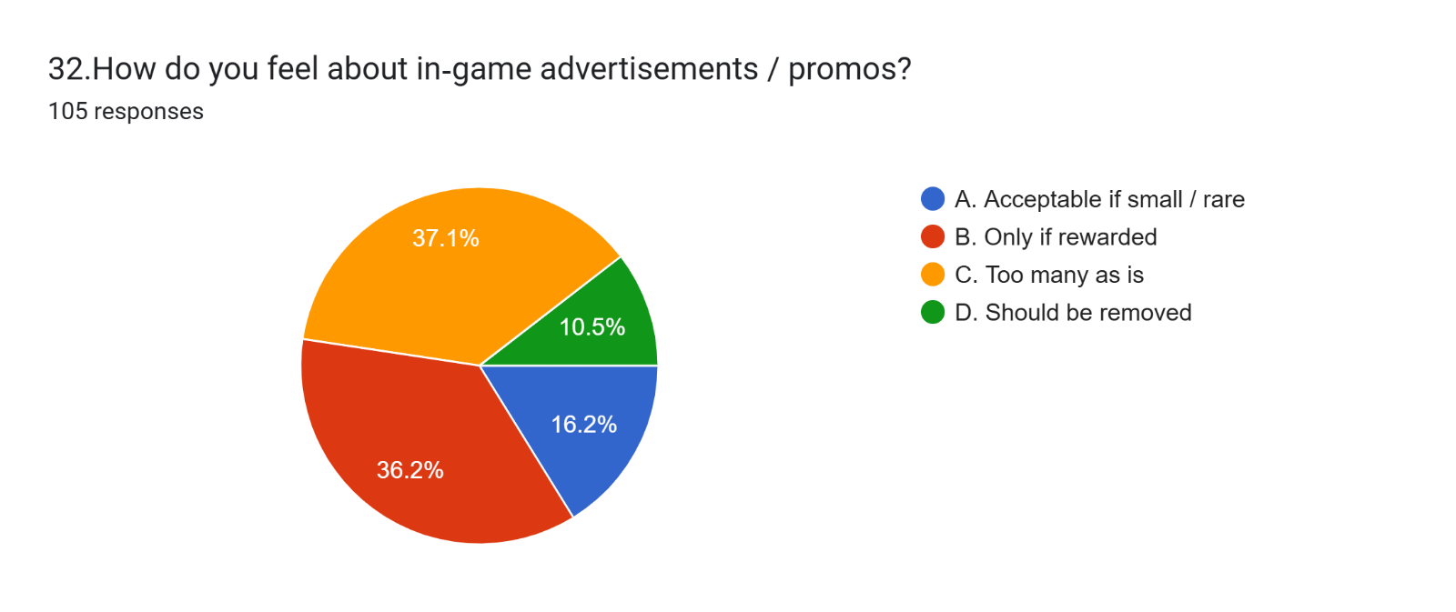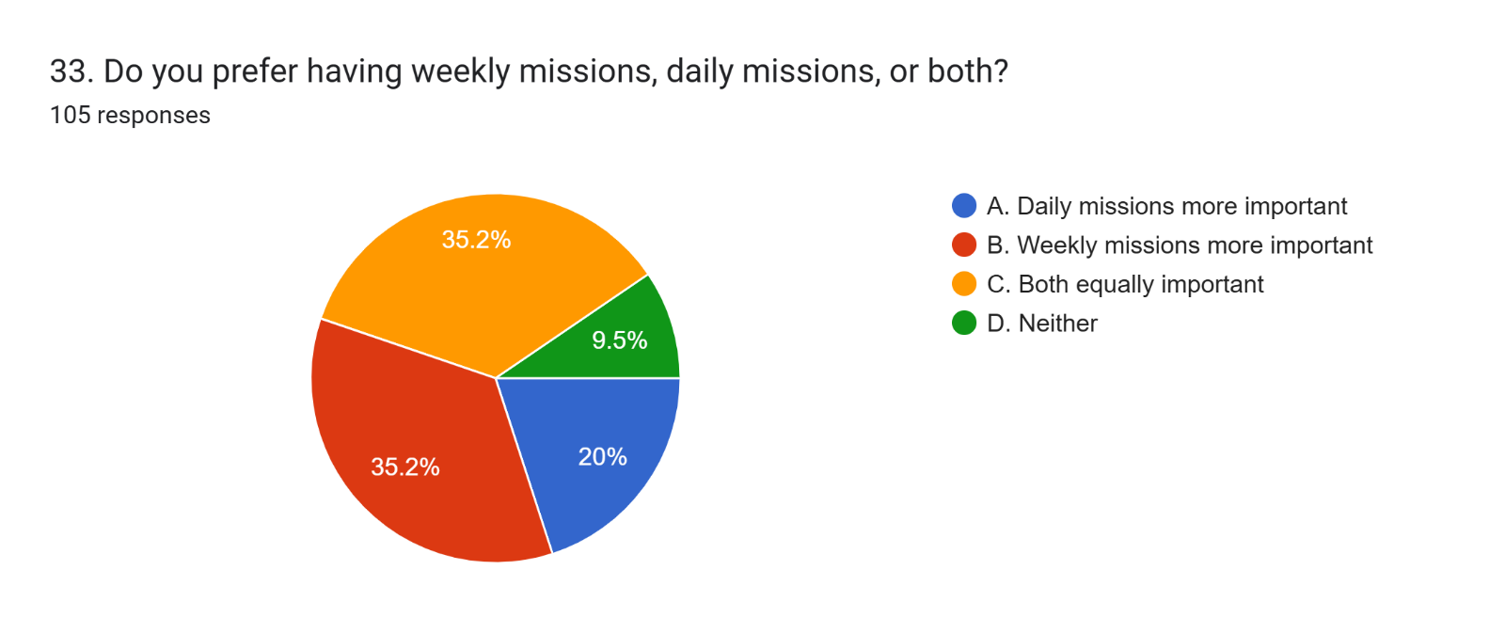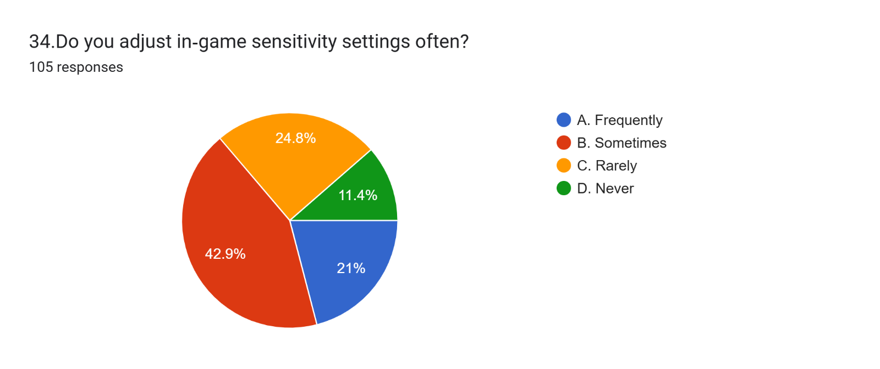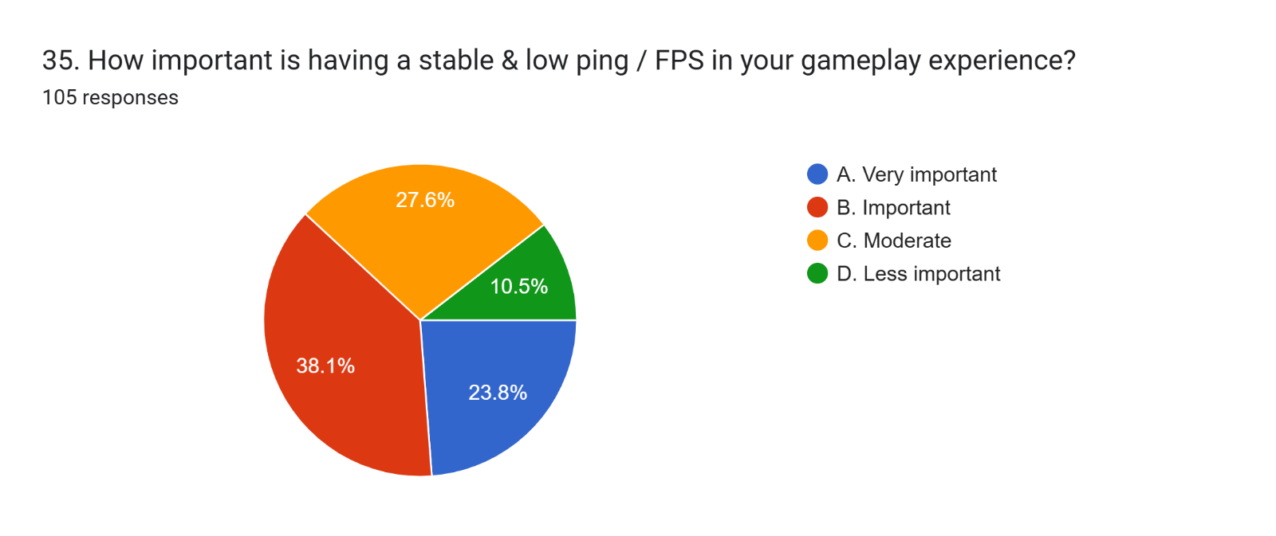Forms response chart. Question title: 36. How often do you change your drop location to try something new?

. Number of responses: 105 responses.Forms response chart. Question title: 37. Does having co‑op / team events enhance your game interest?

. Number of responses: 105 responses.Forms response chart. Question title: 38. How much time do you spend watching Free Fire esports / tournaments per week?

. Number of responses: 105 responses.